

**ÇANKAYA UNIVERSITY FACULTY OF ENGINEERING COMPUTER ENGINEERING DEPARTMENT**

**Project Report**

**Version 1**

**CENG 407**

Innovative System Design and Development I

***P201906***

**AI CUSTOMER SUPPORT SYSTEM**



M.Atakan Demircioğlu - 201511018

Alperen Sarınay - 201511048

M.Cavid Aydın - 201511004

Arınç Alp Eren - 201611020

**Advisor:** Dr. Instructor Roya CHOUPANI

**Co-Advisor:** Dr. Instructor Faris Serdar TAŞEL

Novenber 27th ,2019

Table of Content

1 Literature Search5

1.1 Abstract5

1.2 Introduction5

1.3 About Our Project5

1.4 Why We Choose This Project5

1.5 What Is CRM6

1.5.1 CRM Usage6

1.6 System and Frameworks6

1.6.1 What Is Jenkins6

1.6.2 What Is jQuery7

1.6.3 What Is Bootstrap7

1.7 Why Machine Learning7

1.8 Algorithms7

1.8.1 Machine Learning Algorithms 7

1.9 Dataset8

1.10 Why We Want to Use Web8

1.11 Similar Companies to Our Project8

1.11.1 DigitalGenius8

1.11.2 Maruti Techlabs8

1.11.3 LivePerson8

**2 Sofware Requirement Specification9**

2.1 Introduction9

2.1.1 Purpose and Scope9

2.1.2 Glossary9

2.2 Overall Description10

2.2.1 Product Perspective10

2.2.2 Memory Constraints10

2.2.3 Operations 10

2.2.4 Site Adaptation Requirements10

2.2.5 Product Functions11

2.2.6 Users Characteristics14

2.2.7 Constraints14

2.2.8 Assumptions and Dependencies14

2.3 Specification of Requirements14

2.3.1 External Interface Requirements14

2.3.1.1 User Interfaces14

2.3.1.2 Hardware Interfaces14

2.3.1.3 Software Interfaces14

2.3.1.4 Communication Interfaces14

2.3.1.5 Performance Requirements15

2.3.2 Software System Attributes15

2.3.2.1 Portability15

2.3.2.2 Performance15

2.3.2.3 Adaptability15

2.3.1.4 Safety Requirements15

2.4 Planning16

2.4.1 Team Structure16

2.4.2 Estimations16

2.5 Conclusion16

**3 Software Design Description17**

3.1 Introduction17

3.1.1 Purpose17

3.1.2 Scope17

3.1.3 Glossary17

3.1.4 Overview of Document17

3.1.5 Motivation18

3.2 Design Overview18

3.2.1 Description of Problem18

3.2.2 Technologies Used18

3.2.3 Architecture Design of AI Customer Support System18

3.2.3.1 Profile Page18

3.2.3.2 Question Page19

3.2.3.3 HomePage19

3.2.3.4 Ask Question Page19

3.2.3.5 Install Page20

3.2.4 Class Diagram20

3.2.5 Activity Diagram21

3.3 Use Case Realizations22

3.3.1 AI Customer Support Subsystems22

3.3.1.1 UI Design22

3.3.1.2 Database Design23

3.3.1.3 User Function Design23

3.3.1.4 Administrator Panel Design23

3.3.1.5 Artificial Intelligence Design24

3.3.2 User Interface24

3.3.2.1 Register Page24

3.3.2.2 Login Page24

3.3.2.3 HomePage25

3.3.2.4 Profile Page25

3.3.2.5 Question Page26

3.3.2.6 Ask Question Page26

3.3.2.7 Install Page27

**4 References27**

**1 Literature Search**

* 1. **Abstract**

We design a web-based customer support system that using machine learning. This system can be installed on any website. With our project, we aim to reduce the time wasted and cost of customer service. Artifical Intelligence based support systems are at the center of attention of customers and companies. These systems are rapidly replacing with old systems. In our research, we searched about how artificial intelligence can be integrated into support systems in general and why it should be used.

**1.2 Introduction**

Nowadays, most successful companies provide customer service. A customer support system helps an organization manage customer service requests and interact with customers to resolve them. Customers receive answers to their questions or seek solutions to their problems. Company officials also try to solve problems. It is a very challenging stage for companies to answer questions in a continuous, uninterrupted, accurate and fast manner. Continuous live support to customers is a very high cost. We will work on a much more practical system to reduce the cost of this service. We want to solve the problems of people in this area easier, faster and more accurately. Customers will not expect their questions to be answered by the authorities. They will receive quick answers directly generated by the system. Customers will not expect their questions to be answered by the authorities. They will receive quick answers directly generated by the system. We think this is very important for customer satisfaction.

Our system, which can be installed automatically, will not require any code information from the users and thus the users will be able to use our system easily. We want to create a machine-integrated forum with robust infrastructure with advanced, easy-to-use panels.

In this literature research, we will investigate the following subjects; live support systems, artificial intelligence, machine learning, deep learning, web development, related computer issues, etc.

**1.3 About Our Project**

We are aiming to create a web system that can be installed on any website. In our system, we will be creating a customer support system which is machine learning based program that can train itself according to the questions asked and also answers given by the non-machine (human) supporters. For every website, our program will have its’ own dataset on the computer it is installed. For every solved issue which means question and its’ true answers at the end (does not matter how many questions asked and true or false answers given between these two), machine learning program will create a model and after a while it will start answering questions instead of non-machine supporters.

AI Customer Support will be focused on E-Commerce websites. We will develop our project on this scope. Our project is designed to create its own specific dataset for companies but during development we will use ready datasets to test, train and develop our machine learning algorithm. Also our program can only understand English language.

**1.4 Why We Choose This Project?**

This service is a service where customers can ask the authorities live the problems they have with the company or the product. Customers receive answers to their questions or seek solutions to their problems. Company officials also try to solve problems. It is a very challenging stage for companies to answer questions in a continuous, uninterrupted, accurate and fast manner. Continuous live support to customers is a very high cost. We will work on a much more practical system to reduce the cost of this service. We want to solve the problems of people in this area easier, faster and more accurately.

**1.5 What Is CRM?**

CRM ,which is called Customer Relationship Management, is a technology for managing all your company’s relationships and interactions with customers**[1]**. A CRM is important for companies because every customer can have problems with their products or softwares. To make it easy for customers to stay connected with customer service, companies use CRM. But even though we are in nearly 2020, CRMs are not still automated by machines. Our goal is to create a machine learning based AI system that can handle problems by itself without any help from us, humans.[2]

**1.5.1 CRM Usage**

There are many companies[3] that provides CRM programs for other companies. Many of them are using “Ticketing System” that is mailing to the customer service via CRM program. We are not aiming to create a ticketing program, instead we want a support system that can be used publicly. Like a form, people can interract with other problems and say they have the same problem or offer another solution.

The companies we found throughout our search are not using a system that has any artificial intelligence in it and also many companies use CRMs that use Ticketing System which is we don’t want to use.

**1.6 Systems And Frameworks**

**1.6.1 What Is Jenkins?[4]**

Jenkins is a automation tool. Jenkins is often used by organizations to speed up the software development process. Jenkins provides these with build, deploy and test capabilities that can be provided automatically. This tool writen by Java and it is very important for Continuous Integration. Jenkins is already a server-based application and it can run with Apache web server.

Since we wanted to do Continuous Development while developing the project, we installed this tool on our own compute engine. In this way, we gave everyone the opportunity to work from anywhere. This tool, which is actively working on our server, automatically builds the site files every time the commit comes and everyone can see the change on live.

**1.6.2 What is jQuery?[5]**

JQuery is basicly a JavaScript library that more easy than other JavaScript libraries. Most of biggest companies are using jQuery in development proccess. We choose jQuery to use PHP more dynamically.

**1.6.3 What is Bootstrap?[6]**

Bootstrap is a popular CSS Framework that allowing responsive design. We are considering a responsive design in the project and we decided to use this CSS framework. In this way, we plan a system that works well on all platforms.

**1.7 Why Machine Learning?**

Machine learning is an application of artificial intelligence (AI) that provides systems the ability to automatically learn and improve from experience without being explicitly programmed. Machine learning focuses on the development of computer programs that can access data and use it learn for themselves.[7]

Data is the lifeblood of all business. Data-driven decisions increasingly make the difference between keeping up with competition or falling further behind. Machine learning can be the key to unlocking the value of corporate and customer data and enacting decisions that keep a company ahead of the competition. We asked to ourselves, why don't we use the questions and answers asked to companies as data?

When companies integrate our system, they will use machine learning in the background so that they can provide automatic answers to customers in the live support system.

In our project’s machine learning part, we want to use Python as a programming language. In the light of the information we have found from different source throughout our research, 9 out of 10 sources put Python first. The reasons behind our Python decision are the existence of a massive number of frameworks and libraries for machine learning and great source of information on the internet.[8]

**1.8 Algorithms**

**1.8.1 Machine Learning Algorithms**

Machine learning algorithms can show various success rates depending on the type of data set. It is very difficult to decide exactly which algorithm to use without trying these success rates on the dataset.[10]

In our research we found that we need to use the following algorithms :

5 supervised learning techniques- Linear Regression[11], Logistic Regression, Naïve Bayes, KNN.[12]

3 unsupervised learning techniques- Apriori, K-means, PCA.[13]

**1.9 Dataset**

For our project, companies can share their own datasets (which is consist of questions and answers) with us. Companies may not share their dataset due to security or the dataset may be clasified. If they don’t want to share their dataset, our system will generate its’ own dataset with the help of real human experts. This dataset generation will take some time.

**1.10 Why We Want To Use Web?**

Web development has been improving since its founding.[14] Every company, small businesses, artisans need websites. Also, with the development of the technology sector, serving the customer easily and succesfully has become even more important. As you can see Web Development and Customer Services are non-ending industries. With the help of internet, we aim to reach as many people as we can.

In our project’s web part, we will be using PHP, Python, JavaScript, HTML and CSS as programming languages.[15] HTML, CSS and JavaScript are must programming languages for web development. We will use Python for machine learning program as we mentioned earlier. Also, PHP offers a great database management, dynamic and fast usage. In addition, PHP has a big source of information.

**1.11 Similar Companies To Our Project**

**1.11.1 Company Name : DigitialGenius[16]**

DigitalGenius is an AI platform that uses speech in autopilot to understand conversations, automate repetitive processes. How to use DigitalGenius in customer support operation DigitalGenius is installed as an application to your existing customer service software. Connects your CRM to our AI platform; then train your first buy model and start answering the given questions. Once DigitalGenius is configured and the model is self-taught, you can add it to your agents and start automating incoming queries from start to finish.

**1.11.2 Company Name : Maruti Techlabs[17]**

Wotnot is a chat creation platform that creates intelligent, identifiable bots for your company. WotNot enables your company to automate interactions with your users, obtain information, and manage multiple communication channels. Increases your sales and marketing support with virtual assistant.

**1.11.3 Company Name : LivePerson[18]**

LivePerson is a company that is focused on AI-based Technologies such as chatbot and messaging platforms. LivePerson company has 2 main products which are AI-powered Bots and Messaging Channels.

Messaging channels are an interface between customers and brands via an AI chatbot and makes it easy to find products and purchasing.

AI-powered bots are simply a chatbot creation program that you can automate up to %70 of messaging conversations on your website, SMS, Facebook Messenger, WhatsApp etc.

**2 Software Requirement Specification**

**2.1 Introduction**

**2.1.1 Purpose and Scope**

This document is a software requirement feature for the web application ai customer support project. Main purpose of this document is to give detailed information about the functionalities, constraints and software requirements of the project. The purpose of this document to describe our project, AI Customer Support. The main objective of the project is a system developed to provide faster and more reliable answers to the questions asked in the support parts of e-commerce sites on web platforms. AI Customer Support is a web system that can be installed on any website. In our system, we will be creating a customer support system which is machine learning based program that can train itself according to the questions asked and also answers given by the non-machine (human) supporters. For each website, our program will use its own data set on the computer where it is installed. If there is no data set on the computer, our system will create its own data set for each question asked and the correct answer after installation. For every solved issue which means question and its’ true answers at the end (does not matter how many questions asked and true or false answers given between these two), machine learning program will create a model and after a while it will start answering questions instead of non-machine supporters.

**2.1.2 Glossary**

**Term** **Definitions**

|  |  |
| --- | --- |
| CRM | *Customer Relationship Management  * CRM is a technology that allow you to manage your company’s relationship and interactions between customers. |
| AI | * Artificial Intelligence |
| Machine Learning | * Machine learning is an application of that provides systems the ability to automatically learn and improve from experience without being explicitly programmed. |
| Dataset | * Set of data that is grouped under titles. |

**2.2 Overall Description**

**2.2.1 Product Perspective**

AI Customer Support project is CRM-like system that any E-Commerce based company and business can use it. Our system will have 2 seperate parts. First part is frequently asked questions (FAQ) which is group of questions and answers that are created by admins and also AI itself. Second part is forum that customers can ask questions. These questions can be answered by admins and also with AI system. But because our AI system is machine learning based system, companies must train it. After enough training, AI system will work and answer questions by itself.

**2.2.2 Memory Constraints**

AI Customer Support will require at least 1 CPU, 3GB Ram and minimum 15GB space.

**2.2.3 Operations**

Customers can do several operations on our system. Customers can search for asked questions, which is FAQ, from search bar so they can easily find a solution if the problem already solved. Also customers can share their problems with comunity and create an issue at Forum part. These problems can solved by admins or AI system. After the answers given by admin or AI system, customers should decide whether the solution is true or false. This operation is needed for machine learning training.

On the other hand, if customers decide that the solution is wrong, admins will be notified about this issue so they will solve the problem instead of AI system.

**2.2.4 Site Adaptation Requirements**

Companies must have a website and a domain to use our system. The only thing companies must do is to drag our files to their original website files.

**2.2.5 Product Functions**

AI Customer Support system will have 4 different parts. This parts are Profile, Homepage (All Questions), Question and Sign Up.

**Profile**

* Notification button located on the page navigation bar will open a Pop-Up box that show all the notifications, also user can click on them and will be redirected to the related page.
* With Activity button, user can see all questions they asked before and also by clicking on questions, they can go to the question page.
* Edit Profile button will lead user to the profile options page so they can change their informations like password, email, nickname, profile picture etc.

**Use Case Diagram for Profile Page**

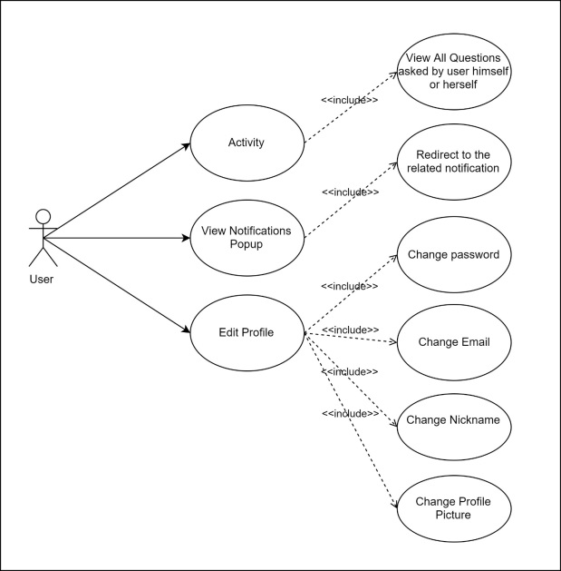

**Homepage (All Questions)**

* Users can input keywords on search box and find their problem if it asked before instead of asking a new questions.
* Filters can be applied on search to make it easy to find the exact problem.
* Time Filters are used to show all question asked since last day, week, month or year.
* Score Filters will sort all questions according to their score in ascending or descending order.
* View Filters will sort all questions according to their view counts in ascending or descending order.
* Show only FAQ Filter will show only Frequently Asked Questions which are created by company owners.
* With Ask Question Button users will be redirected to the page that users can create a question just like on the forum pages. Asked questions won’t be available until it’s marked as “resolved” by user itself. (see Question part)
* By clicking on the question, users will be redirected to the question page.

**Homepage (All Questions) Use Case Diagram**

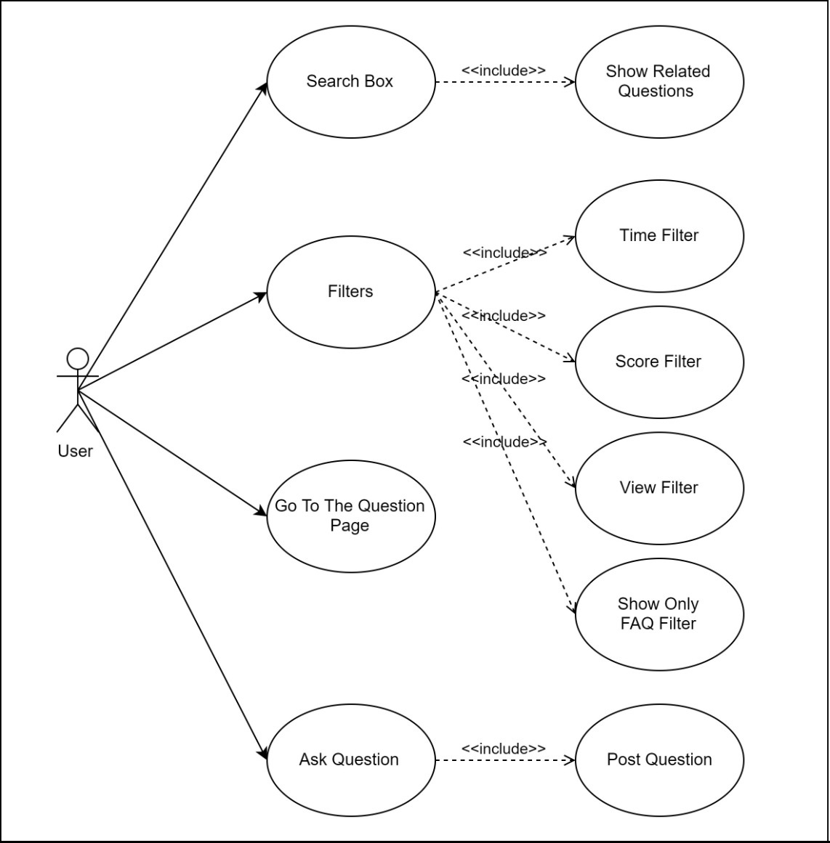

**Question**

* With question voting system, we aim to create a system to create high scored questions so common problems can be found easily by users. Although questions can be voted by users, answers can’t be voted because no answer can be published until it’s fully solved. Because all the answers must be %100 accurate, voting the answers would be meaningless.
* Questions can be answered by only real supporters or AI system.
* Users must verify the answer as “resolved” or “unsolved” so that machine learning can train itself according to accuracy of the answer. Question and related answer won’t be published until users confirm the answer as “resolved” so wrong solutions will not be available in our system.

**Question Use Case Diagram**

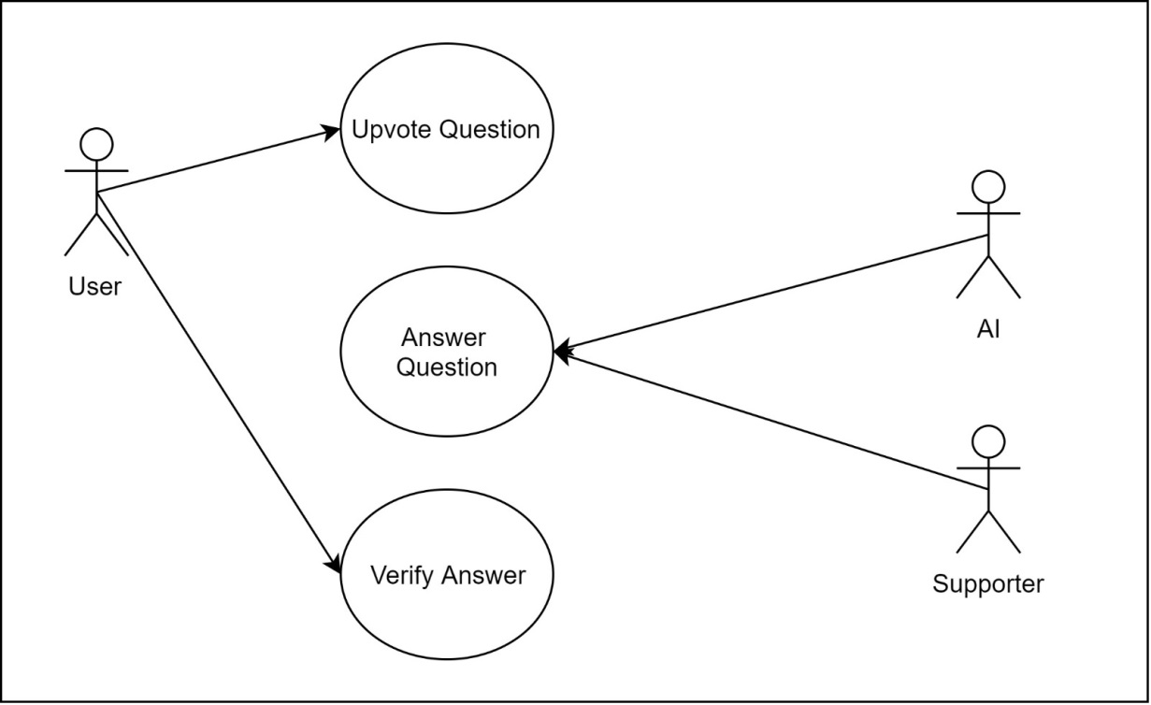

**Sign Up**

* To vote and ask question, users must sign up on our system. On sign up page, users must specify their informations such as name, surname, email, password etc.

**Sign Up Use Case Diagram**

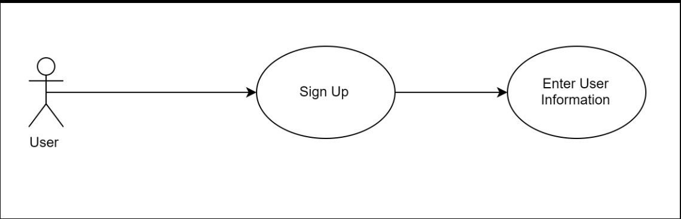

**2.2.6 User Characteristics**

Because of our system designed for English questions and answers, customers and companies should understand English language.

**2.2.7 Constraints**

Our system designed for E-Commerce related customer problems with language of English. So any other topics and languages are not supported. Any website that meets these requirements can use our system.

**2.2.8 Assumptions and Dependencies**

Company website must have PHP on their machine to run our system.

**2.3 Specification of Requirements**

**2.3.1 External Interface Requirements**

**2.3.1.1 User Interfaces**

Our system is a web project and it will have a responsive UI suitable for all platforms. For this we will use bootsrap in the project.

#### **2.3.1.2 Hardware Interfaces**

#### For install the system; user must have a host and probably a domain name. Host must have this system requiretments;

* Minimum 1 CPU
* Minimum 1 GB of RAM
* Minimum 15 GB Space
* Ethernet

#### **2.3.1.3 Software Interfaces**

Any device that (have browser to access internet) can access the website is sufficient to use the system. For install the support System we recommend host supports;

* PHP version 7.3 or greater then this version.
* Linux Or Ubuntu OS
* MySql 5.6 or greater
* HTTPS support (for SSL).

#### **2.3.1.4 Communications Interfaces**

User need a web browser to connect website. For this reason firstly must have internet connection.

#### **2.3.1.5 Performance Requirements**

The most important thing in web-based systems is of course the internet connection. It is also very important that the server can respond to different requests at the same time. For his reason, we will test our software with Apache AB Test before launching. Also we recommend users must test their servers after install our software.

**2.3.2 Software System Attributes**

**2.3.2.1 Portability**

* AI Customer Support will use PHP, Javascript and Phyton. So, our project will be available at all platforms like Mobile Phones, Tablets and PCs.
* The system is a web based project and it not require different hardwares for users. But who installs the software must have a basic host.
* All computers and phones will be avaible to use our system.

**2.3.2.2 Performance**

* Good internet connection is important. Especially the power of the internet where the server is located is very important. Must be fiber. It may be wise to use more than one machine in a wide range of applications, or to separate machines for a database.
* User must have a server that can handle multiple users and multiple requests. For this we have suggested some system requirements above.

#### **2.3.2.3 Adaptability**

#### In the system we have designed, companies will start to keep all the questions asked in their data base as soon as they download AI Customer Support system and adapt it to their website.

#### **2.3.2.4 Safety Requirements**

Since we design a system where customers can easily access everything and receive feedback, it will not cause any inconvenience for our users.

**2.4 Planning**

**2.4.1 Team Structure**

Team Members: Alperen Sarınay, Arınç Alp Eren, M. Atakan Demircioğlu, M. Cavid Aydın.

**Task** **Member**

|  |  |
| --- | --- |
| Web Front-End | Alperen Sarınay – M. Atakan Demircioğlu |
| Web Back-End | M. Atakan Demircioğlu – M. Cavid Aydın |
| UI design | Alperen Sarınay – Arınç Alp Eren |
| Machine Learning | Arınç Alp Eren – M. Cavid Aydın |
| Artificial Intelligence (AI) | Alperen Sarınay – M.Atakan Demircioğlu |
| Dataset Manupilation | M. Cavid Aydın – Arınç Alp Eren |
| Advertisement – Seo | M. Atakan Demircioğlu |

**2.4.2 Estimation**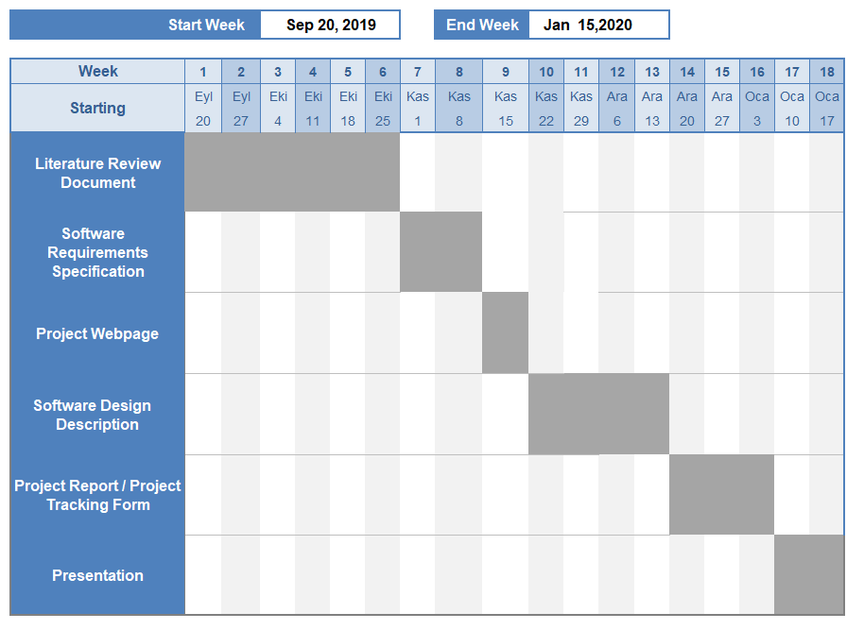

**2.5 Conclusion**

This software document is intended to explain the details, system and hardware requirements of the AI Customer Support system. At the same time, the project we developed will not only be an idea, but also better planning with the models. With the help of our SRS documentation, it will be more easier to implement and use our system on your website.

**3 Software Design Description**

**3.1 Introduction**

**3.1.1 Purpose**

Purpose of this Software Design Document (SDD) is to specify the technical and software requirements of our AI Customer Support Project. For our project, the target auidence is E-Commerce based companies.

**3.1.2 Scope**

This document explains the details of AI Customer Support. AI Customer Support is a system where artificial intelligence answers the questions asked in the support system of internet-based companies. Companies will be able to implement and use this system to their website without writing code.

Artificial intelligence in our system is a system that trains itself by learning the questions asked and the answers given to the questions and in time it starts to give more accurate results. This process continues to train itself until it finds the most accurate answer.

**3.1.3 Glossary**

**Term** **Definitions**

|  |  |
| --- | --- |
| CRM | *Customer Relationship Management  * CRM is a technology that allow you to manage your company’s relationship and interactions between customers. |
| AI | * Artificial Intelligence |
| Machine Learning | * Machine learning is an application of that provides systems the ability to automatically learn and improve from experience without being explicitly programmed. |
| Dataset | * Set of data that is grouped under titles. |

**3.1.4 Overview of Document**

The remainder of the document includes design-related information, Requirements Traceability, User Interface, Input Devices Subsystem, Data Model and Storage, and Data Storage.

**3.1.5 Motivation**

We're a senior in computer engineering. Because of our interest in artificial intelligence and the web sector, we decided to do such a project. In addition, we see that the current position of the web sector in the developing world economy is rising rapidly. Lastly, we can show that Ali Express Company sold 21 billion dollars in the first 6 hours on 11.11.2019[1]. So, we have decided that it is necessary to have support systems that respond automatically in a sector where such high sales figures are achieved.

**3.2 Design Overview**

**3.2.1 Description of Problem**

Nowadays, the use of the Internet has become widespread and most large companies provide their support systems online over the internet. In this sense, we are developing smart support software that they can use without writing code. In addition, users will be answered directly by bots, not people. We will provide this with ai.

**3.2.2 Technologies Used**

Our AI Customer Support system is designed to suit all platforms. In this sense, it is possible to use from mobile, tablets and computers. However, browser and internet connection is required for the devices to be used.

It is recommended that the people who will install our system have domain name and hosting. Because our system is a web-based and online system.

**3.2.3 Architecture Design of AI Customer Support System**

**3.2.3.1 Profile Page**

**Summary :** Users can change or update their information from their profile (password, username, etc ..). They can also track how many questions they have entered into our system.

**Actor :** Users

**Precondition:** User must login.

**Basic Sequence:**

1. User must register if she or he does not have an account.

2. User must login to the system by entering his or her username and password.

3. User can update his or her personal information by selecting “Edit” button from profile page.

4. User must enter new information about himself or herself after clicking “Edit” button and click “Save” button.

**Exception :** If database is not installed , database connection can be failed.

**3.2.3.2 Question Page**

**Summary :** Users can see question , answer and also comments. In addition users can comment on any question.

**Actor :** Users

**Precondition:** None.

**Basic Sequence:**

1. User does not need to login or register for displaying the question page.

2. User must login to the system to comment on questions.

3.User can click any tag for displaying related questions with that tag.

**Exception :** If database is not installed , database connection can be failed.

**3.2.3.3 Home Page**

**Summary :** Users can login, register, search for all questions and apply filter on questions. Also user can go to install page with “install Now” button and go to ask question page with “Ask a Question” button if user is logged in.

**Actor :** Users

**Precondition:** None.

**Basic Sequence:**

1. User does not need to login or register for displaying the home page.

2. User can see question list.

3. User can login or register.

**Exception :** If database is not installed , database connection can be failed.

**3.2.3.4 Ask Question Page**

**Summary :** Users can ask a question and edit the question text.

**Actor :** Users

**Precondition:** User must login.

**Basic Sequence:**

1. User must login to the system by entering his or her username and password.

2. User must enter question title, description, tags and edit description with style button.

3. User can “Submit” the question.

**Exception :** If database is not installed , database connection can be failed.

**3.2.3.5 Install Page**

**Summary :** Admin must enter server name, username, password and database name. Also with the help of checkbox, admin can reset the database.

**Actor :** Admin

**Precondition:** Admin must config the config file.

**Basic Sequence:**

1. Admin must config the config file.

2. Admin must enter server name, username, password and database name.

3.Admin must click “Register” button.

**Exception :** None.

**3.2.4 Class Diagram**

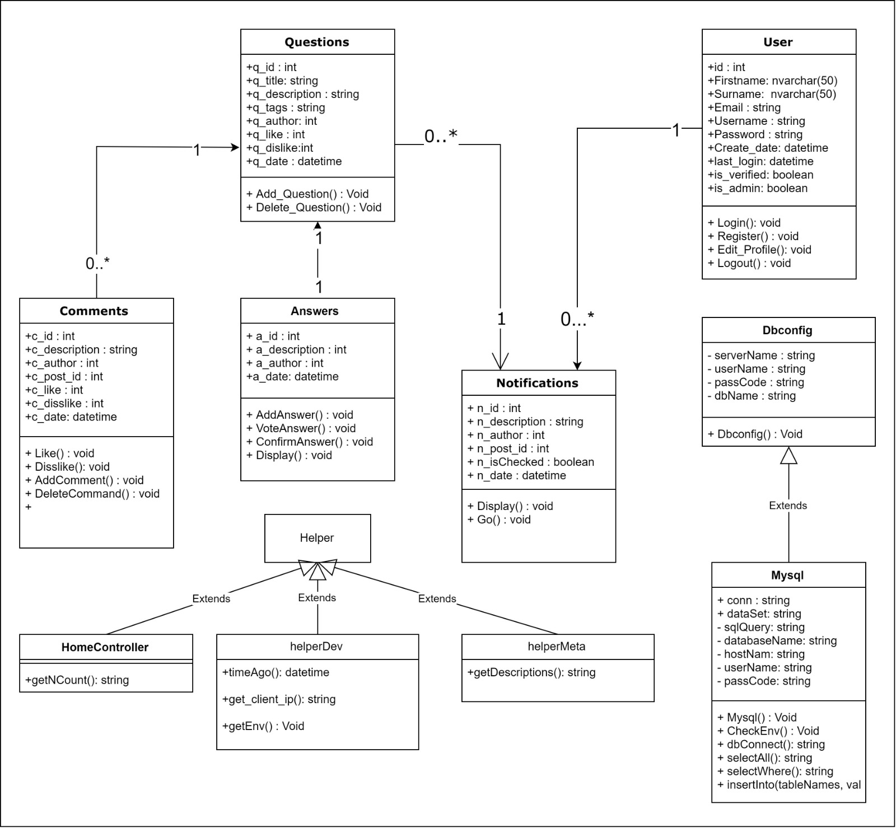

**3.2.5 Activity Diagram**

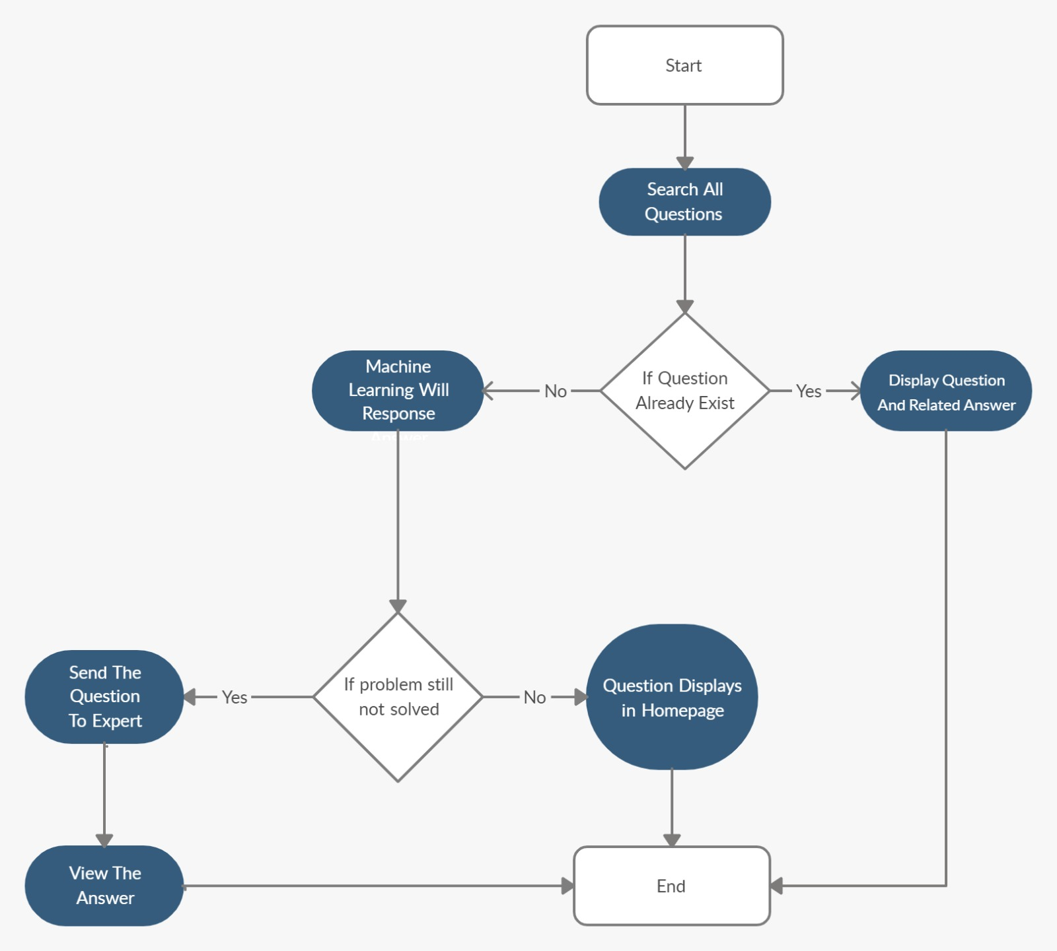

**3.3 USE CASE REALIZATIONS**

**3.3.1 AI Customer Support System**

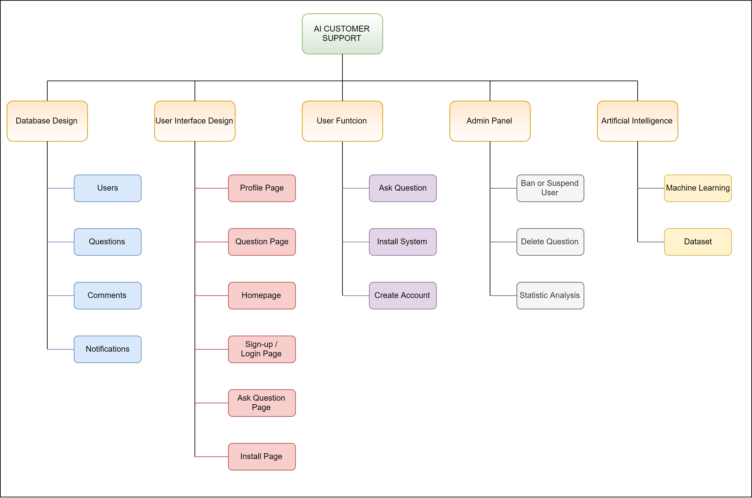

### **3.3.1.1 UI Design**

### The User Interface (UI) design is made to explain the interactions between the user / authorized user and the system. The UI design has six sub-systems:

**Register Page :**  Designed for users to register to the system using their personal information.

(First name, Last name, Username, Email Address, Password)

**Login Page :** Registered users, e-mail addresses and passwords are designed to log in to the system.

**Profile Page :** Designed for allow registered users to view and update their contact information.

**Home Page :** Designed for users to log in, register, search all questions, and filter the questions.

**Install Page :** Designed for users to use the system easily.

**Question Page :** Designed for users to see questions, answers and comments.

**Ask Question Page** : Designed for users to add question.

### **3.3.1.2 Database Design**

Database Design has been made to ensure that the data required for the operation of the system is stored. Essential for database design: entities, tables and relationships.  We will have four entities: Users, Questions, Comments and Notifications.

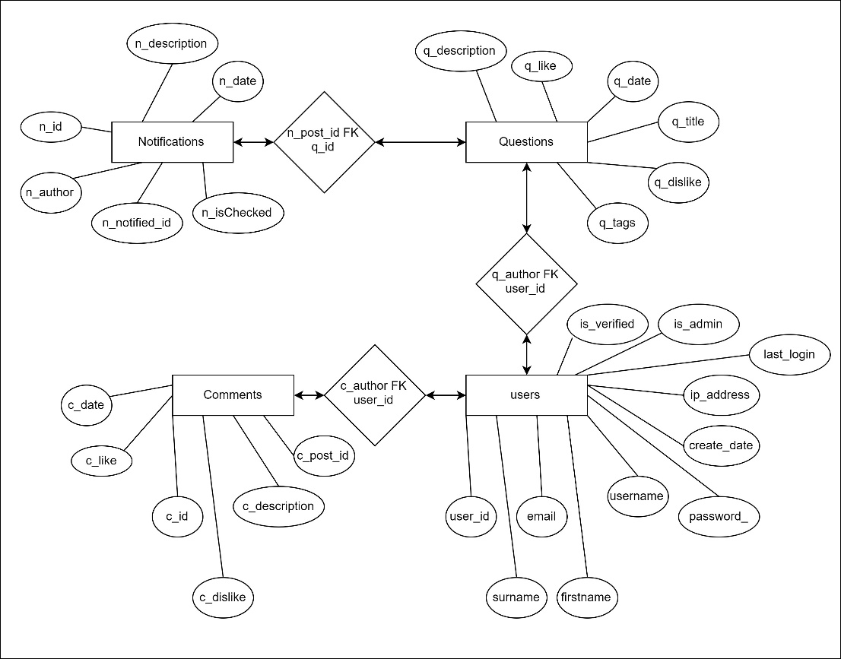

### **3.3.1.3 User Function Design**

Users register to our system after, they will be able to install the customer support system we have prepared for their e-commerce sites. In addition, they will be able to ask any questions or questions they may have about our system on the question page. They will be able to see the questions asked by other users and the automatic answers given by the system we have installed.

**3.3.1.4 Administrator Panel Design**

This panel can be only available and accessible for administrators and experts. Administrator panel lets admins to edit a user or question or comment or anything else. Admins can delete questions, ban or suspend personal accounts. Also admins can analyze many statistics such as how many user using the system or type of questions asked by users.

**3.3.1.5 Artificial Intelligence Design**

For Artificial Intelligence Design, we aim to use one of the best efficient algorithm that we mentioned on Machine learning algorithm part. (Linear Regression, Logistic Regression, Naïve Bayes, KNN, Apriori, K-means and PCA)

## **3.3.2 User Interface**

### **3.3.2.1. Register Page**

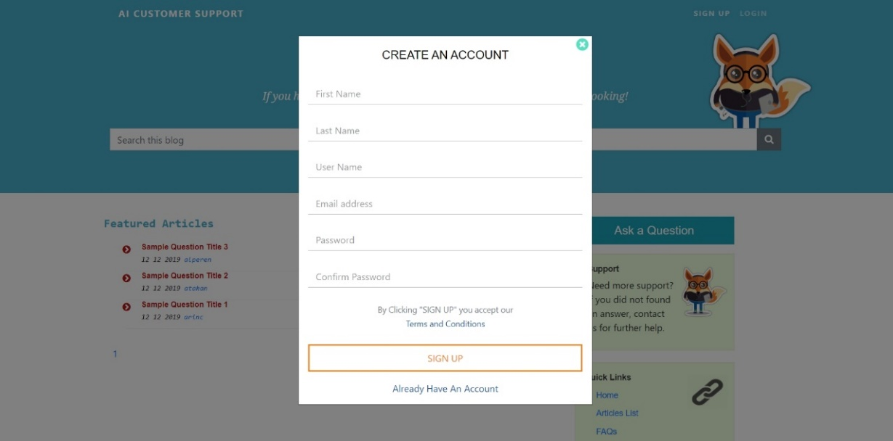

Register page is designed for non-registered users. Users must fill “First Name”, “Last Name”, “User Name”, “Email address”, “Password” and “Confirm Password” parts. Password and Confirm Password must match. Also registered users can click on “Already Have an Account” button and redirect to login page.

### **3.3.2.2 Login Page**

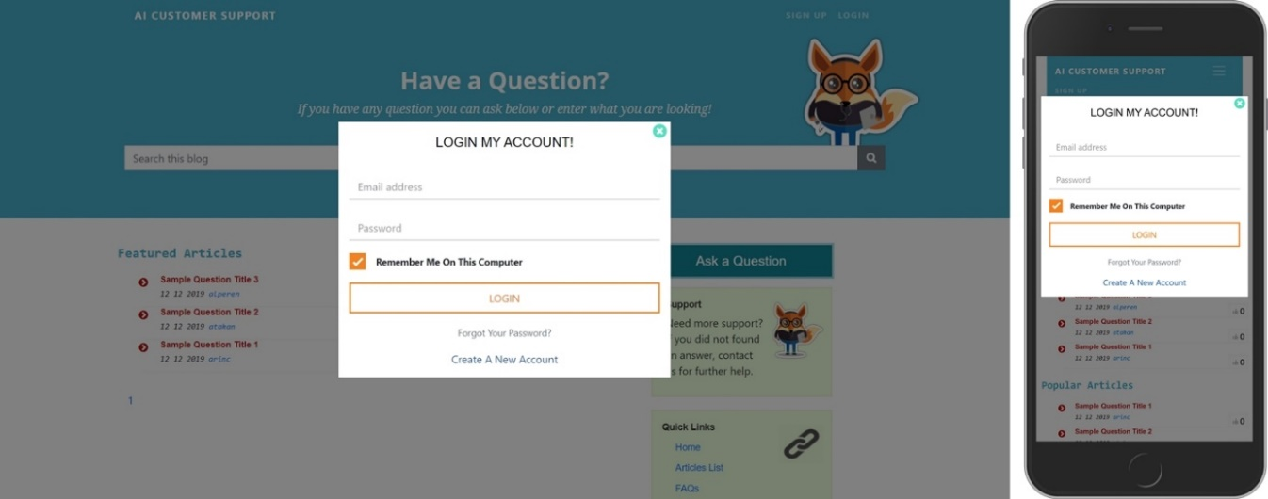

Users must fill the “Email address” and “Password” parts. If any of these informations are incorrect, an alert will show up. Also, if user check the “Remember Me On This Computer” checkbox, users will not need to login again anymore until they logout manually.

## **3.3.2.3 Homepage**

## **1920x1080Homepage-horz**

## On homepage, any user (does not matter if they have account or not) can see featured and popular articles. With search bar, users can search questions by specific keywords across our systems. Also, registered users can ask question with “Ask a Question” button.

## **3.3.2.4 Profile Page**

## **1920x1080Profile-horz**

## Users can see their personal informations such as First Name, Last Name, Email, Username and Password. Also with “Edit” button, users can edit the corresponding information. In addition, asked question count and profile page can be seen on left.

## **3.3.2.5 Question Page**

## **1920x1080SampleQuestion-horz**

## On Question Page, any user (does not matter if they have account or not) can see the related question and tags. Also they can comment on question if comments are allowed.

## **3.3.2.6 Ask Question Page**

## **1920x1080addquestion-horz**

# Registered users can ask question on this page. With the buttons, they can edit their question description. Users must fill the Question Title, Description, Tags and Submit.

## **3.3.2.7 Install Page**

# C:\Users\Alperen Sarınay\Desktop\install-horz.jpg

# Install page is only available for administrator. With install page, owners must fill the “Servername”, “Username”, “Password”, “DB Name” and Register. With “Reset Database” checkbox, admins can reset database.

# **4. References**

[1] <https://www.salesforce.com/crm/what-is-crm/>

[2] <https://www.superoffice.com/blog/what-is-crm/>

[3] <https://freshdesk.com/tr> , <https://www.zoho.com/desk/> , <https://www.salesforce.com/eu/>

[4] <https://jenkins.io/>

[5] <https://jquery.com/>

[6] <https://getbootstrap.com/>

[7] <https://searchenterpriseai.techtarget.com/definition/machine-learning-ML>

[8] <https://www.springboard.com/blog/best-programming-language-for-ai/>

<https://www.geeksforgeeks.org/top-5-best-programming-languages-for-artificial-intelligence-field/>

<https://becominghuman.ai/5-best-programming-languages-to-choose-for-developing-innovative-ai-solutions-bac000e00df2>

<https://medium.com/duomly-blockchain-online-courses/the-best-programming-language-for-artificial-intelligence-and-machine-learning-538486b462c>

<https://www.itproportal.com/features/top-five-programming-languages-for-ai-and-machine-learning-you-should-learn-this-year/>

<https://www.quora.com/What-is-best-programming-language-for-Artificial-Intelligence-projects>

<https://existek.com/blog/ai-programming-and-ai-programming-languages/>

<https://www.endivesoftware.com.au/blog/5-best-programming-languages-for-ai-development>

<https://www.futureproofing.io/blog/the-5-best-programming-languages-for-ai-development>

<https://hub.packtpub.com/top-languages-for-artificial-intelligence-development/>

[10] <https://www.analyticsvidhya.com/blog/2017/09/common-machine-learning-algorithms/>

[11] Shai Shalev-Shwartzz-Shai Ben-David, Understanding Machine Learning, pages 123-126

[12] <https://towardsdatascience.com/linear-regression-detailed-view-ea73175f6e86>

[13]<https://towardsdatascience.com/understanding-k-means-clustering-in-machine-learning-6a6e67336aa1>

[14]<https://www.fullstackacademy.com/blog/nine-best-programming-languages-to-learn-2018>

[15] <https://www.statista.com/statistics/617136/digital-population-worldwide/>

[16] <https://www.digitalgenius.com/>

[17] <https://marutitech.com/>

[18] <https://www.liveperson.com/>